**Week 5 Microservices Mandatory HandsOn Solutions**

**Creating Microservices for account and loan**

**Account Microservice**

**Step 1: Setup Directory Structure**

1. Create a folder with your **employee ID** in D: drive (example: D:\123456)
2. Inside it, create a subfolder named microservices
   * Final path: D:\123456\microservices

**Step 2: Create Account Microservice**

• Open https://start.spring.io/ in browser

• Enter form field values as specified below:

o Group: com.cognizant

o Artifact: account

• Select the following modules

o Developer Tools > Spring Boot DevTools

o Web > Spring Web

• Click generate and download the zip file

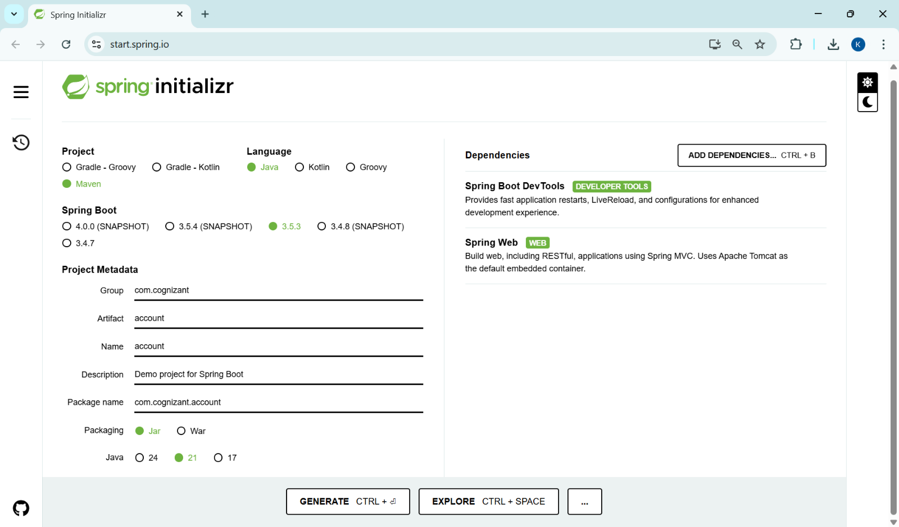

**Step 3: Build Account Project using Command Prompt**

* Open command prompt in account folder and build using mvn clean package command

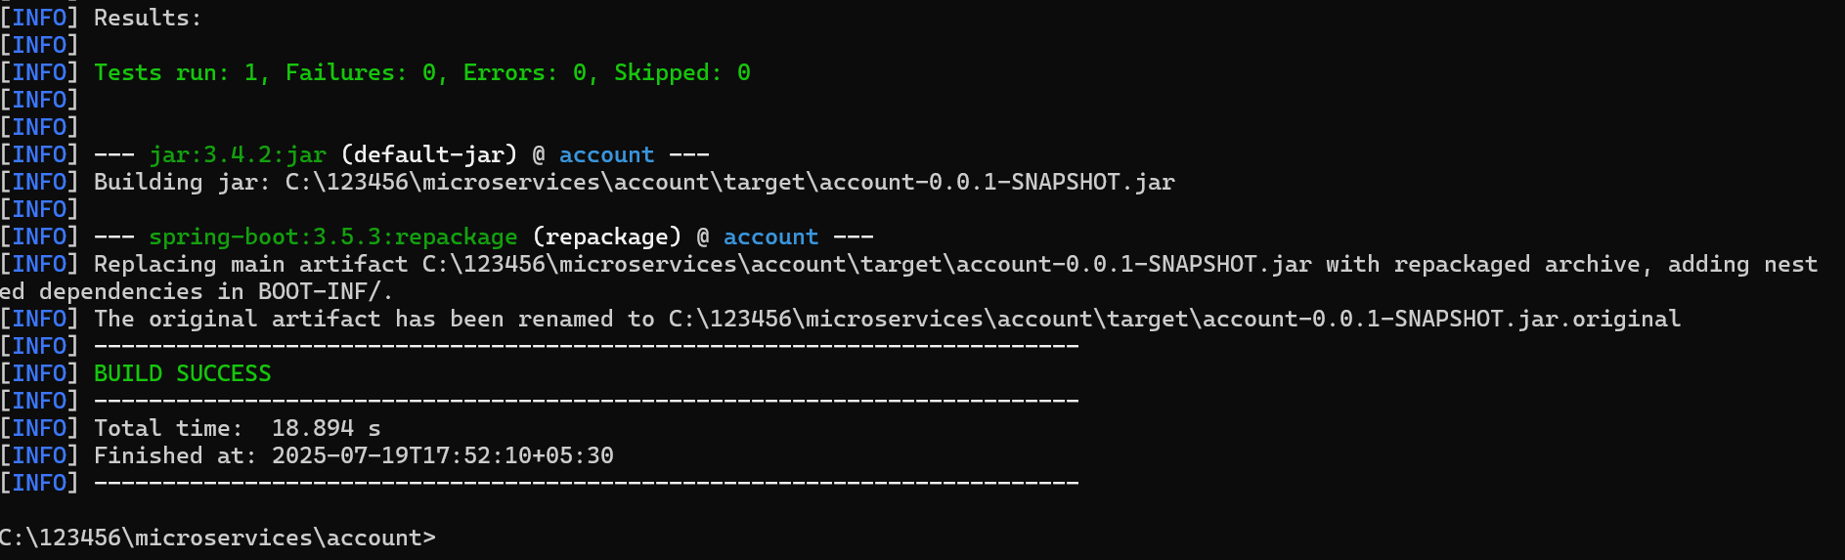

**Step 4: Import Account Project into Eclipse**

* Import this project in Eclipse

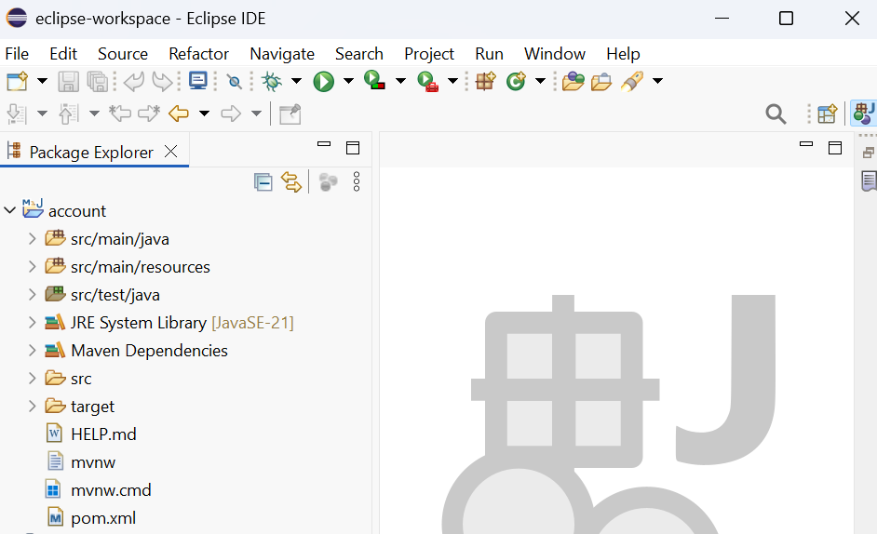

**Step 5: Add Controller in Account Microservice**

* implement a controller method for getting account details based on account number. Refer specification below:

o Method: GET

o Endpoint: /accounts/{number}

o Sample Response.

Just a dummy response without any backend connectivity.

{ number: "00987987973432", type: "savings", balance: 234343 }

**AccountController.java**

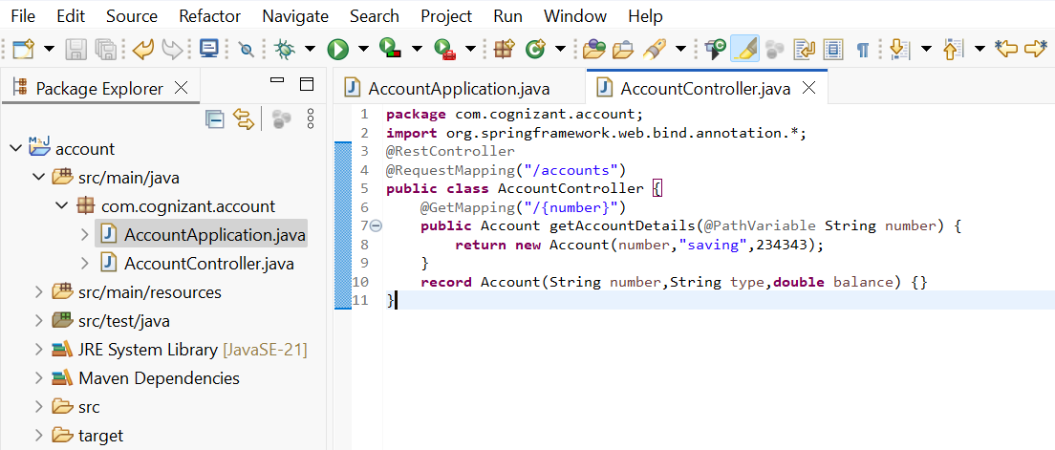

**AccountApplication.java**

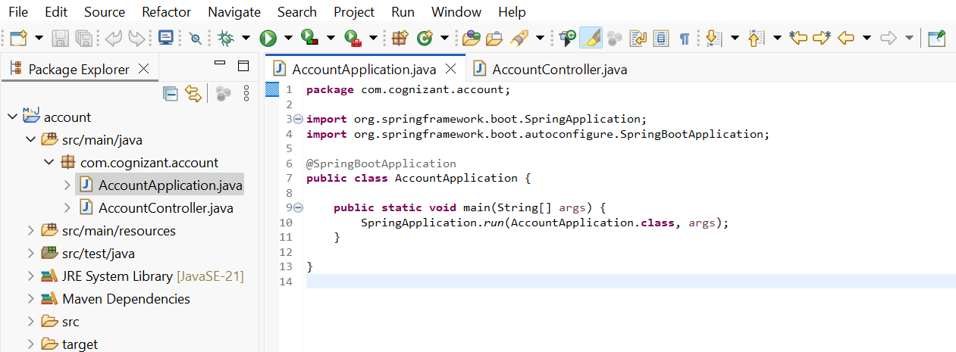

**Output:**

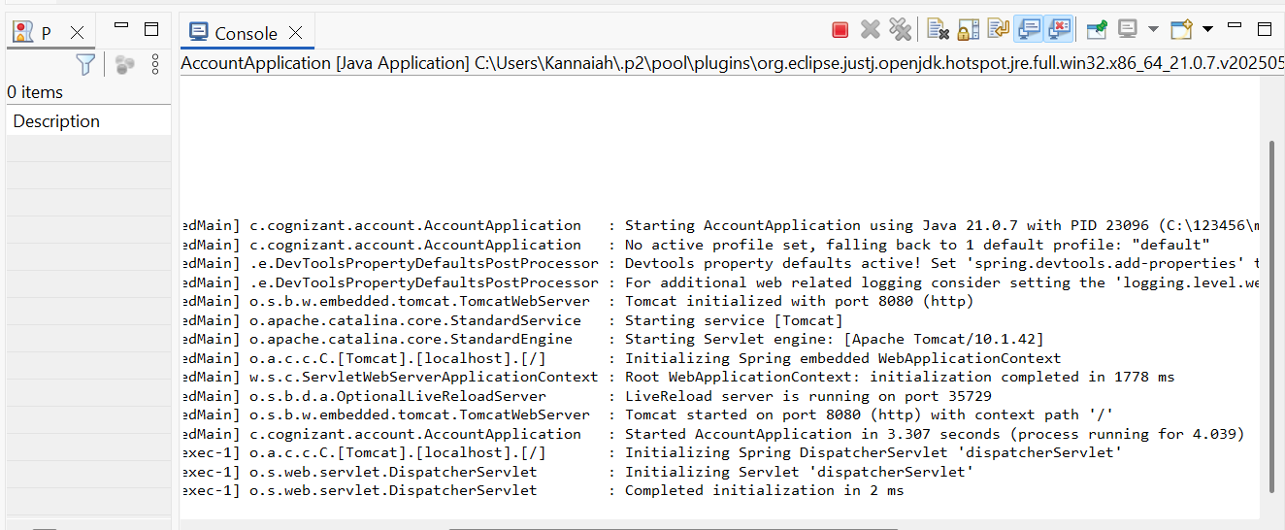

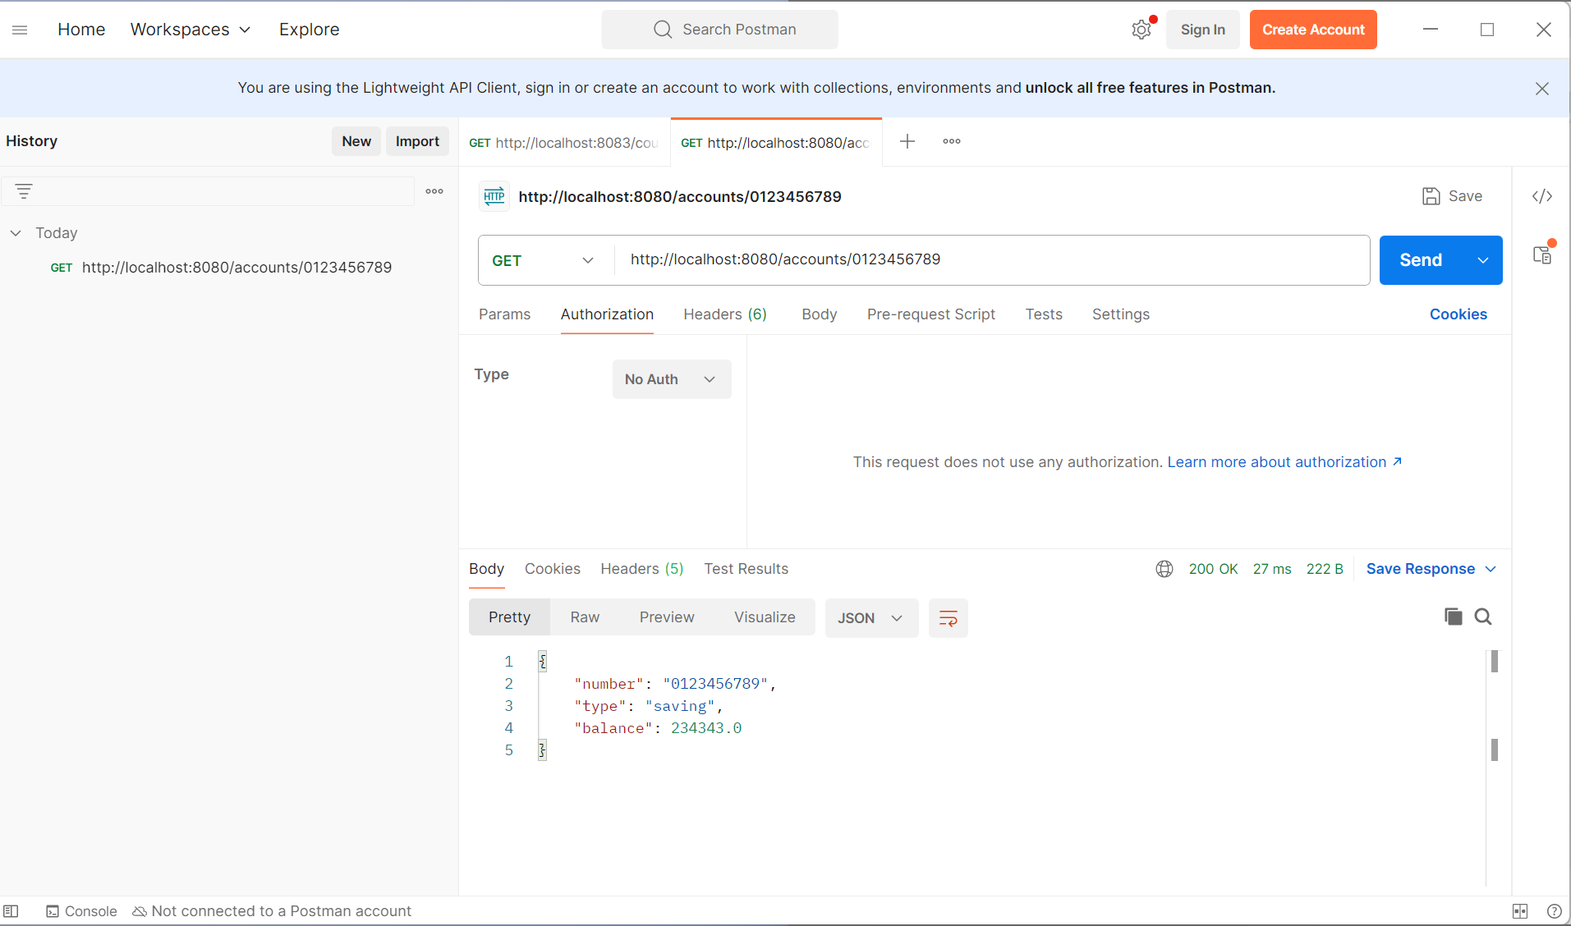

**For Loan Service**

* Follow similar steps specified for Account Microservice and implement a service API to get loan account details

o Method: GET

o Endpoint: /loans/{number}

o Sample Response.

Just a dummy response without any backend connectivity.

{ number: "H00987987972342", type: "car", loan: 400000, emi: 3258, tenure: 18 }

* Launching this application by having account service already running
* This launch will fail with error that the bind address is already in use
* The reason is that each one of the service is launched with default port number as 8080. Account service is already using this port and it is not available for loan service.
* Include "server.port" property with value 8081 and try launching the application
* Test the service with 8081 port

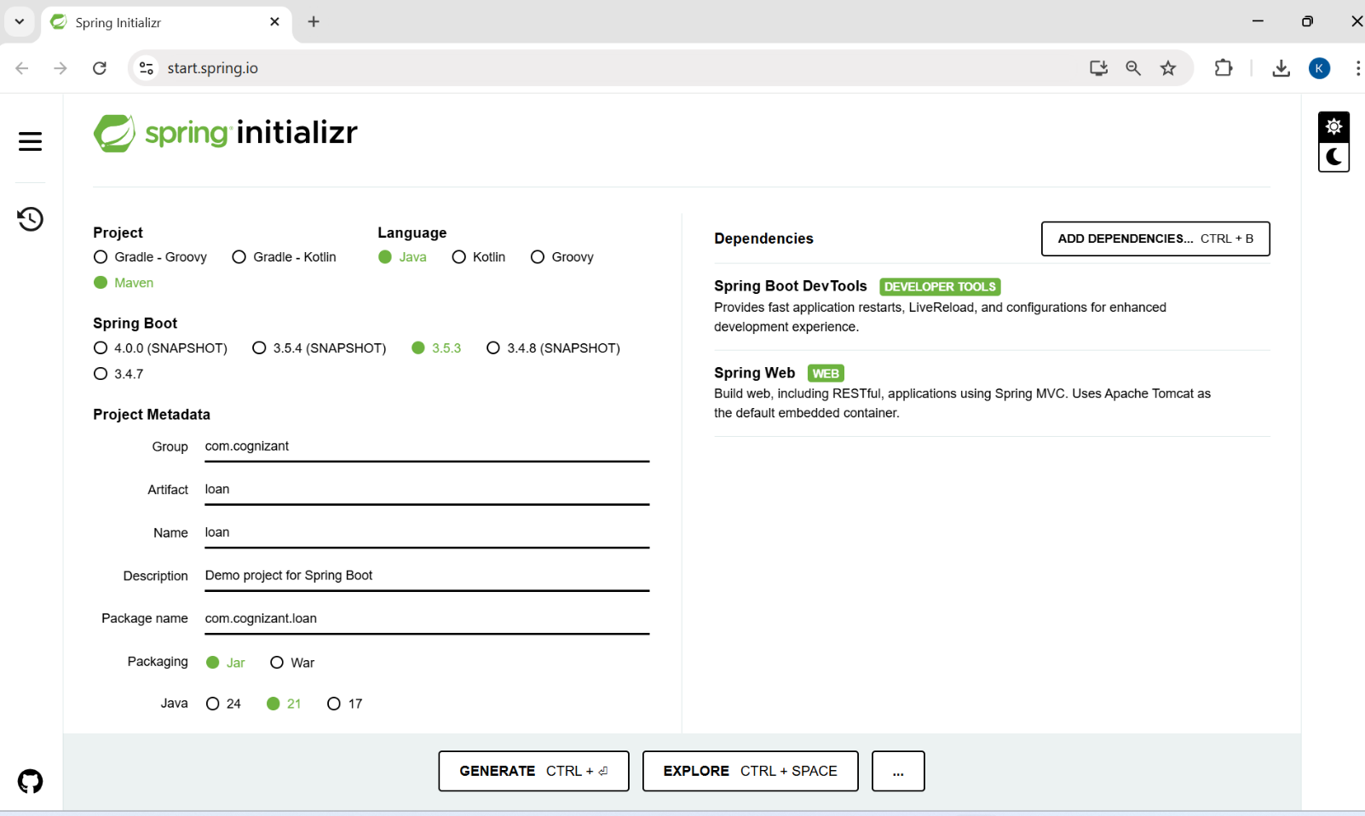

**LoanController.java**

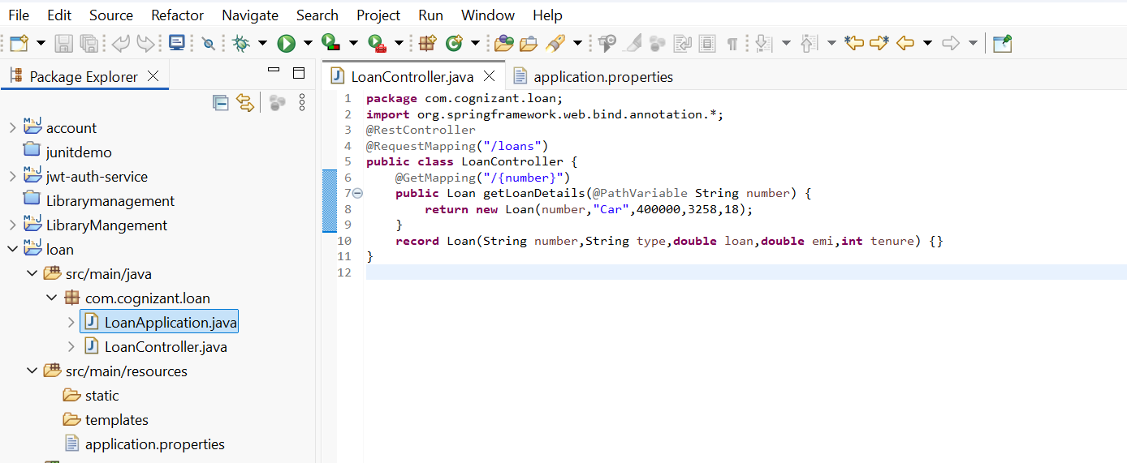

**LoanApplication.java**

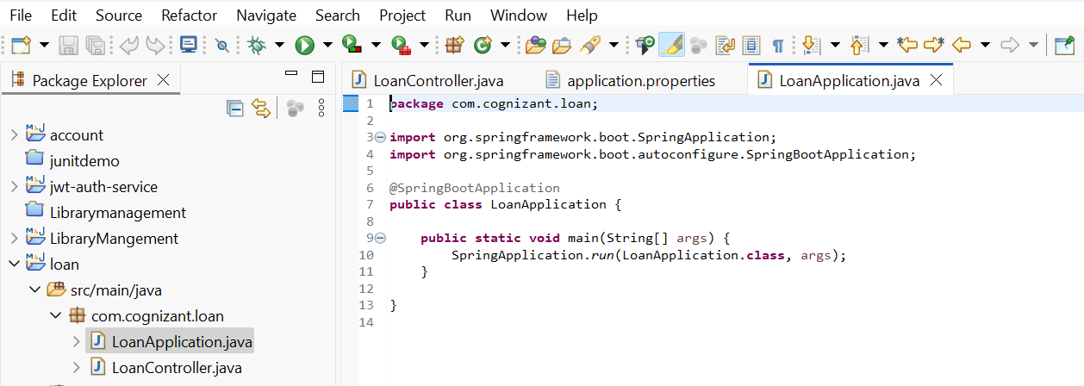

**Application. Properties**

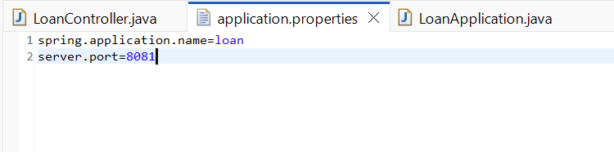

**Output:**

